**Design Document**

**«House of Thorns»**

House of Thorns – a VR game in which player is a man who just need to escape the room and reveal some secrets along the way.

Controls 2

Interface 2

Plot 3

Gameplay 5

Locations 6

Items 8

Documents 9

Player’s replicas 12

1. **Control**

Player’s controls is

1. **Interface**

POV – first person.

Interface in this game is fully immersive. Player sees only hands of a hero and an inventory, which is shows by pressing a right trigger.

Interaction cursor has several settings:

* Hand – appears when cursor is pointed on object that player can place in the inventory.
* Gear – appears when cursor is pointed on object that player can interact with an item from inventory.
* Eye – appears when cursor is pointed on objects that player can examine.

1. **Plot**

Year 1833

Protagonist wakes up in a semi-dark room lighted by a moonlight. On a bedside table there’s a letter. (***Letter from Father***)

Beside letter lies a key which he takes. Young man tries to open a front door which leads to the freedom, but the key does not fit.

Young man looks around the room. It was pretty big – with massive window, impossible to open (he tried), double bed with ornaments, ancient furniture, just for his great-grandpa, a bunch of paintings, large and tiny, candelabrums on the wall. The room was a little messy like every little thing is out of order.

He notices a painting with a young woman on it. It was turned left a little. Young man came to look closer and notices that something is hiding beside it. It was a safe with 4-digits combination.

Looking further the room young man founds an old stethoscope and the box of matches. From the candelabras on the wall, he takes one candle.

Beside the bed, in the dark corner he finds a small chest. Right on the top of it there was engraved two letters M.T., like on the key. It was the key from this chest.

In the chest he finds some old clothing, an old letters and a piece of paper with a three digits. (***Piece of paper with incomplete password***)

Young man thinks that these digits will open the safe. He types them on the safe and for the last he listens the safe with and old stethoscope. Finally, he opens the safe.

Inside, he finds a blank parchment. Young man inspects it and discovers a strong lemon scent. This can mean that this is an invisible ink. He fires the candle and holds it on the letter. Words shows up forming some text. (***Letter from safe***)

After reading, young man came to the bed to find a stone from the letter. Moments later he pushed the right stone and part of the wall opened. In this secret stash lies a key. Young man tried to open the front door again but it was useless.

What can I open in this room? – he asks himself. The room was full of furniture, but nothing with a keyhole.

Maybe, if there is a one secret stash, maybe there is another? – he thought. With this he started to push and pull everything in this room. Finally, he finds a candelabra which turned with a rattling noise.

Nearby wall moved completely, opening not a secret stash, but a whole secret room. Young man came into this room fully blinded by darkness. In the dim light from the previous room, he saw other candelabras on the wall and lighted them.

This room was not just old, but ancient. Young man wondered how many secrets this house holds. Right at this moment he realized that this test was only to reveal dark secrets of Thornhill family to him. Cold fear covered him as he thought what awaits him. What this room holds.

Looking all over this room he finds an old oak table on which is a couple of old letters on foreign language, paper is so old that parchment is already turning into dust. Also, there is an inkpot full of well-preserved ink, an old ink pen and an ornament smoking pipe.

Beside table there is two rotten, but still strong chests and three barrels with unknown contents. Chests was firmly closed with a rusty lock.

Young man tries a key on one of the chests and he opens. Inside, there is something that he doesn’t expect to see. Something dreadful…

Inside was various documents – for the houses and properties in England and in other countries, issued on unknown peoples. But some of the names was well-known to him. It was his great-grandpa, his grandpa and his father.

So, this is the source of family wealth. Stolen houses, missing owners – that was the big family secret. A burden to live with.

For a moment he thought how may it happen – he goes to study abroad, he lives with Mary and their future children, how it all will be wonderful. But for now, only burden of dreadful secrets was the only thing in his mind.

On the bottom of the chest, he found another key. That key opened the second chest. In that chest were packs of old bills, golden bars, a scattering of gemstones and other valuables. On the top there is a small notebook in which was some names and dates of death, and a Certificate of Inheritance. All properties, all houses and belongings were rewritten to his name. And he cannot sell any of this because all family crimes will be exposed. All what’s left is keeping this history to the Thornhill’s descendants, which will be passed on further.

Beside these documents lies a heavy golden key. Adrian knows it is a key to the front door.

Now when he knows exactly what father inherited to him, there is a choice for him – to hide these secrets like the generations before him or expose them to the publicity killing the Thornhill’s reputation.

**Endings**

* ***Keeper of Thornhill Secrets*** – Adrian opens the front door and leaves, becoming the keeper of a dreadful secret.
* ***Hand It On*** – Adrian writes a letter, in which he describes every single detail about crimes of Thornhills and attaches all documents. Then he leaves this house no longer hoping for a normal life.
* ***Secret Ending (Gone With The Blow)*** – Adrian set the barrel on fire and blows himself up with the bloody history of Thornhill.

1. **Gameplay**

Animation of the player waking up turns on. Then player looks around and takes the letter and the key from the bedside table. He reads the letter and understands that key is for the front door. When the key does not fit, player begins to search the room to find some clues. Player is having a freedom to explore.

On the coffee table he finds a box of matches. From one of the candelabras, he takes one candle (when he interacts with other candles hero talks: “I already have this”). In the dresser he finds an old stethoscope. Also, behind the painting player finds a safe with a puzzle (4-digits combination). Next discover is the chest near the bed. Chest is locked but key in the inventory will fit. Inside there is some old clothing, several old letters and piece of paper with three digits. Player understands that this is a code to the safe and tries to type it in the safe. The fourth digit can be found with a stethoscope. Player uses it on the safe and puzzle begins. Player must scroll the digits listening to the sounds of it. When the digit is right, safe opens.

Inside lies an old blank parchment (in this moment hero says: “Hmm, a scent of lemon…”). Player understands that this is an invisible ink. He fires up a candle and uses it on the parchment. It reveals another letter from father. From it player discovers a location of a secret stash behind the bed. He interacts with one of the stones and stash opens. A key lies within it

There is no place for key in this room, so player searches the room again and finds that one of the candelabras in turning, opening a passage to the secret room. It is very dark here and player lights the candelabras in this room by burning candle. In this room there is a table, two chests in the corner, old crates, three barrels, some wooden planks. Player takes an old ink pen from the table. Key from the stash fits to one of the chests, in which are documents exposing the family crimes and another key which fits to the second chest. In this chest are various jewelery, gold and gemstones. Also, there is a ***notebook***, ***key*** and ***Certificate of Inheritance***. After reading this documents, player replica begins (look ***Player’s Replicas***)

This moment is the “crossroad” for several game endings.

1. ***Keeper of Thorhhill Secrets*** – player escapes the secret room and opens a front door.
2. ***Hand It On*** – player uses an old ink pen on the inkpot and in the inventory appears the ***Confession*** document. After this player opens a front door and escapes.
3. ***Secret Ending (Gone With The Blow)*** – player uses the burning candle on the barrels in the secret room. Everything blows up.
4. **Locations**

* Main room

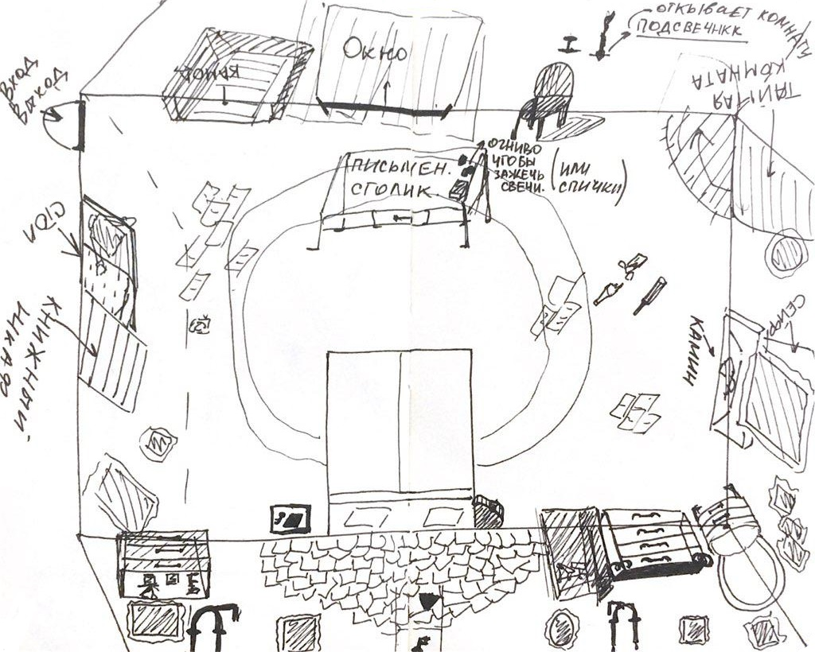

* Secret room

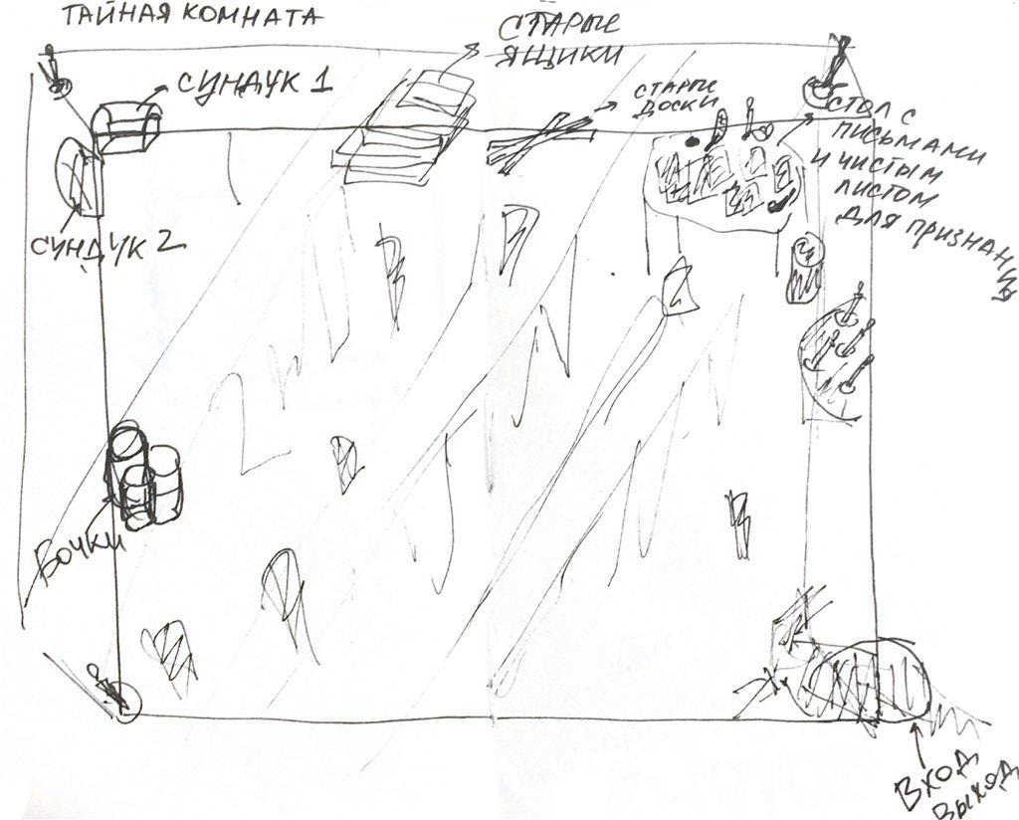

1. **Items**

* Magnifying glass (to read the documents again)
* Key with initials
* Candle/Burning candle
* Matches
* Old stethoscope
* Key from the secret stash
* Old ink pen
* Key from the first chest
* Key from the second chest
* Letter from father
* Piece of paper with incomplete password
* Letter from safe
* Note from The Telegraph Post
* Strange note
* Property sale agreement
* Money transaction receipt
* Certificate of inheritance
* Confession

1. **Documents**

* ***Letter from my father***

*«To Adrian. My testament.*

*My beloved son! I can’t express how much I am grateful to the fate for what a person you are now! It feels like only yesterday I held your little body in my hands. And now I look at you and I can’t get enough of how wonderful man you are.*

*Unfortunately, I have to leave this earth sooner or later, but you must know – I will be beside you for eternity. Anywhere you go - just know that I will be always with you.*

*I am so sorry that I’ll miss your wedding. Mary is a wonderful girl and you are a very lucky man. And I’m glad that our Thornhill family will not perish.*

*With this letter I want to give you my last instructions, Adrian. Look after your mother will you. I know that it’ll not be easy for her. You must support her in this hour. Keep the righteous path my son and it will always lead you to the happiness.*

*And the last, but not least thing. I am giving our house to you. Your mother already told me that she will leave this place after I’m gone. It is very important that this house cannot be abandoned. Don’t ask me why. You must become a keeper of Thornhill history.*

*My only requirement is that you must spend one day in the bedroom of great-grandfather Melvin. You can consider it as some sort of test. I already arranged everything. Your mother Aylene will lock you. After 24 hours you can leave this place, I’ll attach the key with the letter.*

*Now I can rest in peace. I am very proud of you, son.*

*Your loving father,*

*Richard James Tornhill»*

* ***Piece of paper with incomplete password***

*«127…» (4)*

* ***Letter from safe***

*«My dear Adrian.*

*As you can see now, I lied. That key, it didn’t open that door. It opens another door. The door you don’t want to open. Ever. You must face the darkest secrets of Thornhill family.*

*This place contains many secrets kept for decades by our family. Me, your grandfather and great-grandfather, we passed this secrets on to our sons. I am asking you to do the same thing. Especially because your son will be born soon.*

*Мне невыразимо больно взваливать на тебя такой тяжёлый груз, но это то, что должно будет произойти, чтобы Торнхиллы продолжали существовать…  
I’ll help you find one key, but you must keep the greatest secret of this home only to yourself and pass it on further. Like everyone else… before you. You’ll find the key in the wall behind the bed.  
Just press the right stone»*

* ***Note from The Telegraph Post***

*«Yesterday, August the 5th, body of 30-year-old male was found on Wayling Way. Constables was able to identify the victim. It was some Walton Jerring, a banker from capital and a successful businessman, manager of the London Brick Factory. One of the witnesses – Malvin Thornhill – the constables about some mysterious figure who ran into the dark alley nearby minutes before police arrival. We’ll keep following this case in hope to revealing the criminal’s identity»*

* ***Strange note***

*«М.Т. 12:00 Daxfort*

*The Hunt*

*Harry has the guns*

*After they yours»*

* ***Property sale agreement***

*«This document secures the transaction between mr. Jonathan Palvert and mr. Abercromby Thornhill for the purchase of the house located on 11 Greencoat Row.*

*Owner mr. Jonathan Palvert accepts from Mr. Abercrombie Thornhill, 1000 pounds as a full payment for the house.*

*October the 29th 1725»*

* ***Money transaction reciept***

*«I, mr. Oliver Wigglebaum, willing to pay 2700 pounds for murder of Jonathan Palvert to sir Abercrombie Thornhill.*

*28 октября, 1725 года.»*

* ***Notebook***

*«Oliver Sykes, 1670, 1500£*

*Aaron Cahill, 1682, 300£, D-fort*

*Walton Jerring, 1694, 2100£, f-ry*

*Michael Thornsby, 1700, 790£*

*Gregory Pack, 1711, 3200£*

*Jonathan Palvert, 1725, 2700£, h-se*

*Marlow Heading, 1740, 1700£*

*Morgan Richardson, 1759, 5000£*

*Lawrence Watersby, 1780, 2500£, bre-ry*

*Arthur Fishborn, 1799, 6300£*

*Barnie Ladlow, 1830, 6800£»*

* ***Certificate of Inheritance***

*«I, mr. Dorian Andrew Holmes, certified notary, confirm that Adrian Thornhill is the rightful heir to the property of Richard Thornhill by the right of birth and blood.*

*Property contains:*

*Ancestral house, located on 11 Greencoat Row*

*Hunting grounds in Daxfort, south of Cambridge*

*Country house, located on 12 Abrecromby Way, Harlow*

*London Brick Factory, located on 13 Orlando Road, London*

*Full set of hunting rifles, left for safekeeping to me, mr. Holmes*

*The key to the cell 36709 in The Bank of England.*

*This document confirms the ownership of Adrian Thornhill.*

*December the 14th 1832»*

* ***Confession***

*«Scotland Yard, Head Constable.*

*Adrian Thornhill»*

1. **Player’s replicas**

* When he wakes up

*«The time has come…»*

* When he used the key with initials on the door

*«Strange… This had to be the right key…»*

* When he opens the chest with initials

*«What does it mean, father? »*

* When he looks at the painting with the safe behind

*«She reminds me of someone. Maybe this is my great-grandmother Erin»*

* When he opens the secret stash with the key

*«How many secrets this place contains? »*

* When he opens the secret room

*«I am sinking into the abyss of madness…»*

* When he opens the second chest in the secret room

*«Oh, no! Father, why did you curse me with this burden? »*

* After he reads the **Certificate of Inheritance**

*«How will I live with this burden?*

*How can I pass it on to my child?*

*I can turn myself in to the police. I can write it all. The crimes of my family.*

*Or… I can lock everything inside my mind. Shove it into the very dark corner. And I can go back to Mary.*

*This choice will define my whole life.*

*Mary…*

*I just want you to be here…»*